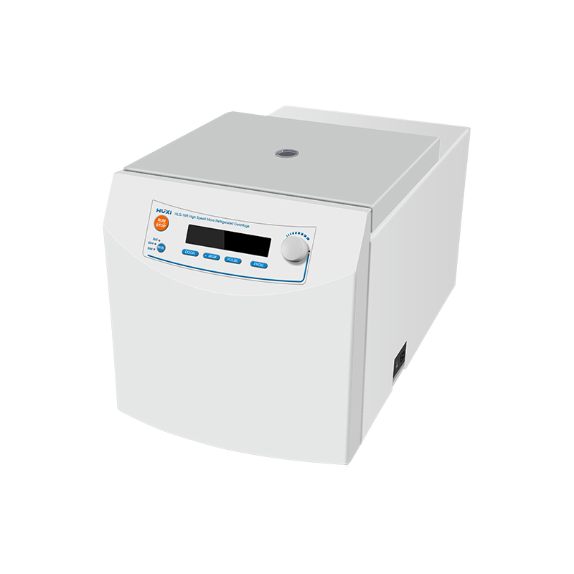

# **HLG-16R High Speed Micro Freeze Centrifuge**

# **Shaker**

# HT-S330 **Rotary Shaker**

**Application：**

HLG-16R high speed micro freezing centrifuge can reach up to 16200rpm, with the performance and structure of freezing centrifuge, less capacity, using miniature brushless DC motor, fast lifting speed, no dust, maintenance-free. Imported SECOP compressor, 5 minutes to cool down to 4 ℃. These centrifuges are mostly used to collect microorganisms, cell debris, cells, large organelles, sulfuric acid precipitates, and immune precipitates, etc.

**Main Features：**

* Suitable for the separation of DNA, RNA and proteins in molecular biology;
* Maximum speed up to 16200rpm (25000×g);
* Bio-sealed rotor;
* Imported SECOP compressor, 5 minutes cooling down to 4℃;
* 9 sets of custom program storage, 4-speed down curve;
* Maintenance-free DC brushless motors;
* Unique MSM operation mode, slow speed up/down operation mode;
* Automatic fault diagnosis.

**Technical Parameters：**

|  |  |
| --- | --- |
| Model | HLG-16R HLG-16R |
| Speed display | LCD |
| Speed range(rpm) | 300~16200 |
| Speed accuracy(rpm) | 100 |
| FCR Range(×g) | 10~25000 |
| FCR Accuracy(×g) | 100 |
| Max Volume | 2ml×48 |
| Standard rotor | 24×2ml |
| Timer range | 10s~99min |
| Working mode | Continuous |
| Speed accuracy(rpm) | ±20 |
| Temp set range(℃) | -20~40 |
| Noise level(dB) | ≤55 |
| Power Supply | AC 220V, 50Hz/60Hz, 10A |
| Exterior Dimension(mm) | (L)292×(D)405×(H)226 |
| Weight(kg) | 34 |